

Bachelor of Computer Applications
Semester – V
Deep Learning

Project – 09
Title: Optimizer Comparison Using a Neural Network

Submitted By:
Poojashree H
Reg. No.: 2411021240046
Date: 08/10/2026

Submitted To:

Faculty Name: Nagasri p

Department of Computer Application Alliance University
Chandapura - Anekal Main Road, Anekal Bengaluru – 562106

OCTOBER 2026

Github link : https://github.com/Pooja27-web/Deep-Learning

Objective

The objective of this project is to build a simple neural network on the Iris dataset and compare two optimization algorithms, Stochastic Gradient Descent (SGD) and Adam. The comparison looks at how each optimizer behaves during training (speed of convergence) and how well the resulting model classifies unseen data.

Dataset Description

The Iris dataset contains 150 samples of iris flowers from three species: Setosa, Versicolor, and Virginica. Each sample has four features: sepal length, sepal width, petal length, and petal width. The data was split 80/20 into 120 training and 30 test samples (stratified, so each class is equally represented), and the features were standardized using StandardScaler.

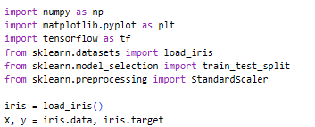

Methodology

Network Architecture (Task 1)

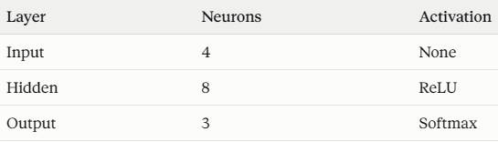

A fixed random seed was set before building each model so that both optimizers started from identical initial weights. Any difference in results is therefore due to the optimizer alone.

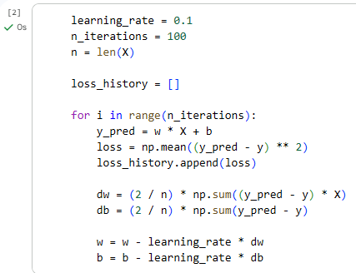

Training with SGD and Adam (Task 2)

Both models were trained with identical settings so the comparison is fair:

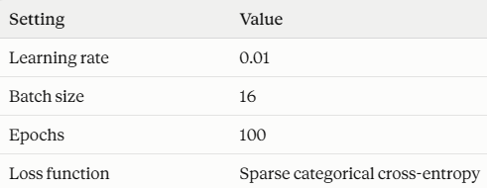

- SGD updates every weight using the gradient scaled by one fixed learning rate.
- Adam adapts the step size for each weight using running averages of past gradients and squared gradients, which usually speeds up convergence.

Loss Tracking and Visualization (Task 3)

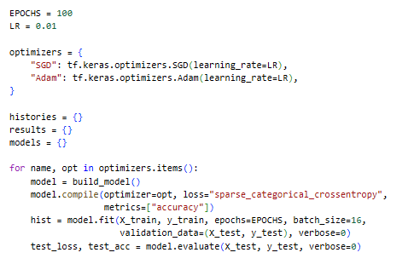.

Evaluation

After training, each model was evaluated on the test set. Final loss and accuracy were recorded, a classification report (precision, recall, F1-score) was generated for each model, and training loss and accuracy were plotted across epochs for both optimizers.

Results

Overall Performance

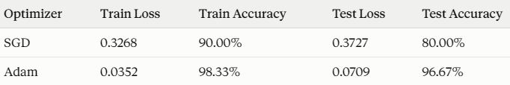

Speed of Convergence

Adam's training loss fell below 0.30 by epoch 9. SGD did not reach this level within 100 epochs.

Per-Class Performance (Test Set)

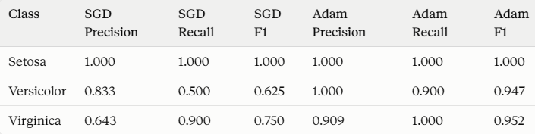

Training Curves

The plot (optimizer_comparison.png) shows training loss and accuracy across 100 epochs for both optimizers. Adam's loss drops steeply in the first ~15 epochs and then flattens near 0.04, while SGD's loss decreases slowly and steadily and is still falling at epoch 100. Adam's accuracy climbs above 95% within about 15 epochs, while SGD's rises gradually to 90%.

Discussion

- Convergence speed: Adam converged much faster because it adjusts the step size for each weight individually. SGD with a plain learning rate of 0.01 takes small, uniform steps, so it needs many more epochs to reach the same loss.
- Classification quality: Both models separated Setosa perfectly, since it is clearly distinct from the other two species. The gap appeared on Versicolor and Virginica, whose features overlap. SGD's undertrained model confused them (Versicolor recall of only 0.50), while Adam handled them with F1 scores near 0.95.
- SGD is slower here, not incapable: SGD was still improving when training stopped. With more epochs, a higher learning rate, or momentum, it would likely close much of the gap.
- Limitations: The test set has only 30 samples, so the difference between 80% and 96.7% corresponds to about 5 predictions. The results come from a single run with one seed. The overall trend (Adam converges faster under identical settings) is reliable, but the exact accuracy gap could vary with a different data split or random seed.

Conclusion

This project compared SGD and Adam on a small neural network trained on the Iris dataset under identical conditions. Adam trained faster and reached better performance, with a test accuracy of 96.67% against 80.00% for SGD and a much lower final loss. SGD is simpler and still improving at the end of training, so it would need more epochs or tuning to compete. For quick, small-scale training like this, Adam is the stronger default choice, while SGD remains a useful baseline for understanding how optimization works.

